 | Pimpri-Chinchwad Education Trust’s  Pimpri-Chinchwad College of Engineering  (An Autonomous Institute)  Affiliated to Savitriăai Phule Pune University (SPPU) ISO 21001:2018 Certified ăy TUV
Assignment No 1

Name: Mohit Ashok Sojal PRN:124B1F027
Subject: Design and Analysis of Algorithms Batch:A2
GitHub Link: https://github.com/mohitsojal1/DAA--Assignment

1. Aim
To design and implement the Merge Sort algorithm using the Divide and Conquer strategy to efficiently arrange customer orders according to their timestamps, and to analyze its time and space complexity for large datasets.

2. Problem Statement
Design and implement a sorting algorithm using Merge Sort to efficiently arrange customer orders based on their timestamps. The solution should be capable of handling a large dataset of up to 1 million customer orders with minimal computational overhead. The performance of Merge Sort should also be analyzed in terms of:
- Best-case time complexity
- Average-case time complexity
- Worst-case time complexity
- Space complexity
Its performance should also be compared with traditional sorting algorithms such as Bubble Sort, Insertion Sort, and Quick Sort.

3. Course Objectives
- To understand the basics of computational complexity and the performance analysis of algorithms.
- To select appropriate algorithm design strategies for solving real-world computational problems.
- To understand and apply the Divide and Conquer paradigm.
- To implement an efficient sorting algorithm for handling large datasets.

4. Course Outcomes
- Analyze the asymptotic performance of algorithms.
- Solve computational problems by applying suitable algorithmic paradigms such as Divide and Conquer and Greedy methodologies.
- Compare different algorithms based on their time and space requirements.
- Apply suitable algorithms to real-world problems involving large datasets.

5. Theory
Merge Sort is a popular sorting algorithm known for its efficiency and stability. It follows the divide and conquer approach. It works by recursively dividing the input array into two halves, recursively sorting each half, and finally merging them back together to obtain the sorted array.

5.1 Working of Merge Sort
- Divide: Keep dividing the list or array into two equal halves again and again, until each part has only one element left.
- Conquer: Each sub-array is sorted individually using the merge sort algorithm.
- Merge: The sorted sub-arrays are merged back together in sorted order. The process continues until all elements from both sub-arrays have been merged.

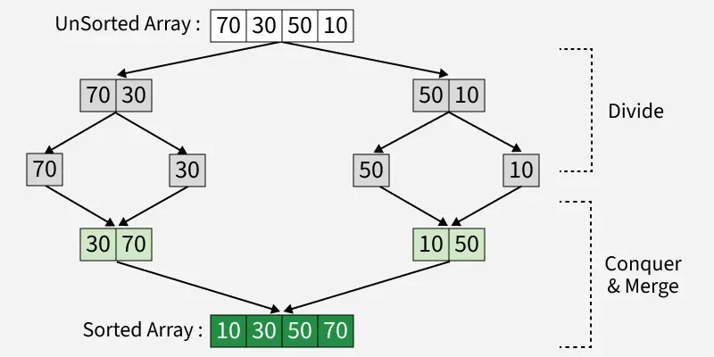

Fig. 1 — Working of Merge Sort (Divide, Conquer & Merge)

5.2 Complexity Analysis of Merge Sort
Divide step: The array is recursively divided into two halves until each subarray has one element. The number of times an array of size n can be divided is log₂(n), which is the height of the recursion tree.
Merge step: At each level of recursion, all n elements are merged.
Total work = number of levels × work per level = log₂(n) × n = O(n log n)

5.3 Time Complexity
Best Case: Even if the array is already sorted, Merge Sort still divides and merges every element. Merging sorted sub-arrays still requires scanning through all elements. Best Case = O(n log n)
Average Case: For randomly arranged data, the algorithm still divides into halves and merges them. On average, the number of comparisons during merging is proportional to n. Average Case = O(n log n)
Worst Case: Even if the array is sorted in descending order (the worst arrangement for comparisons), Merge Sort still performs the same divide-and-merge procedure. Comparisons may be maximum, but are still bounded by O(n log n). Worst Case = O(n log n)

5.4 Space Complexity
In Merge Sort, all elements are copied into an auxiliary array of size N, where N is the number of elements in the unsorted array. Hence, the space complexity of Merge Sort is O(N).

6. Merge Sort Algorithm
- If there is only one element in the list, consider it already sorted and return.
- Divide the list recursively into two halves until it can no longer be divided.
- Merge the smaller lists into a new list in sorted order.

Pseudocode — MERGE_SORT
MERGE_SORT(array, left, right)

if left >= right
return

mid = (left + right) / 2

MERGE_SORT(array, left, mid)
MERGE_SORT(array, mid + 1, right)

MERGE(array, left, mid, right)

Pseudocode — MERGE Procedure
MERGE(array, left, mid, right)

create temporary array temp
i = left ; j = mid + 1 ; k = 0

while i <= mid and j <= right
if array[i] <= array[j]
temp[k] = array[i] ; i = i + 1
else
temp[k] = array[j] ; j = j + 1
k = k + 1

while i <= mid
temp[k] = array[i] ; i = i + 1 ; k = k + 1

while j <= right
temp[k] = array[j] ; j = j + 1 ; k = k + 1

copy temp into array[left...right]

7. Flow Diagram
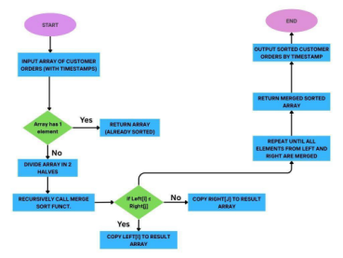

Fig. 2 — Flowchart of the Merge Sort process

8. Comparison with Traditional Sorting Algorithms
Algorithm | Best Case | Average Case | Worst Case | Space | Stable
Bubble Sort | O(n) | O(n²) | O(n²) | O(1) | Yes
Insertion Sort | O(n) | O(n²) | O(n²) | O(1) | Yes
Selection Sort | O(n²) | O(n²) | O(n²) | O(1) | No
Quick Sort | O(n log n) | O(n log n) | O(n²) | O(log n)* | Usually No
Merge Sort | O(n log n) | O(n log n) | O(n log n) | O(n) | Yes
*Recursion-stack space for Quick Sort's in-place partitioning.

9. Worked Example
Customer order timestamps: [12:30, 09:15, 14:45, 10:00]
Step 1 — Divide: Split into halves → [12:30, 09:15] and [14:45, 10:00]; further split → [12:30], [09:15], [14:45], [10:00].
Step 2 — Merge & Sort: Merge [12:30] and [09:15] → [09:15, 12:30]. Merge [14:45] and [10:00] → [10:00, 14:45]. Merge the final two halves → [09:15, 10:00, 12:30, 14:45].
Output: Orders sorted by timestamp → [09:15, 10:00, 12:30, 14:45]

10. Implementation
The source code, sample dataset, and execution output for this assignment are available at the GitHub repository link on the cover page of this document.

11. Conclusion
Merge Sort is a highly efficient and stable sorting algorithm that organizes customer orders based on their timestamps with O(n log n) complexity. Compared to traditional algorithms like Bubble Sort or Insertion Sort, which are too slow for large inputs, Merge Sort can easily handle up to 1 million records without performance issues. Its ability to maintain the correct order and scale predictably makes it an excellent choice for real-world applications such as e-commerce, order tracking, and scheduling systems.

